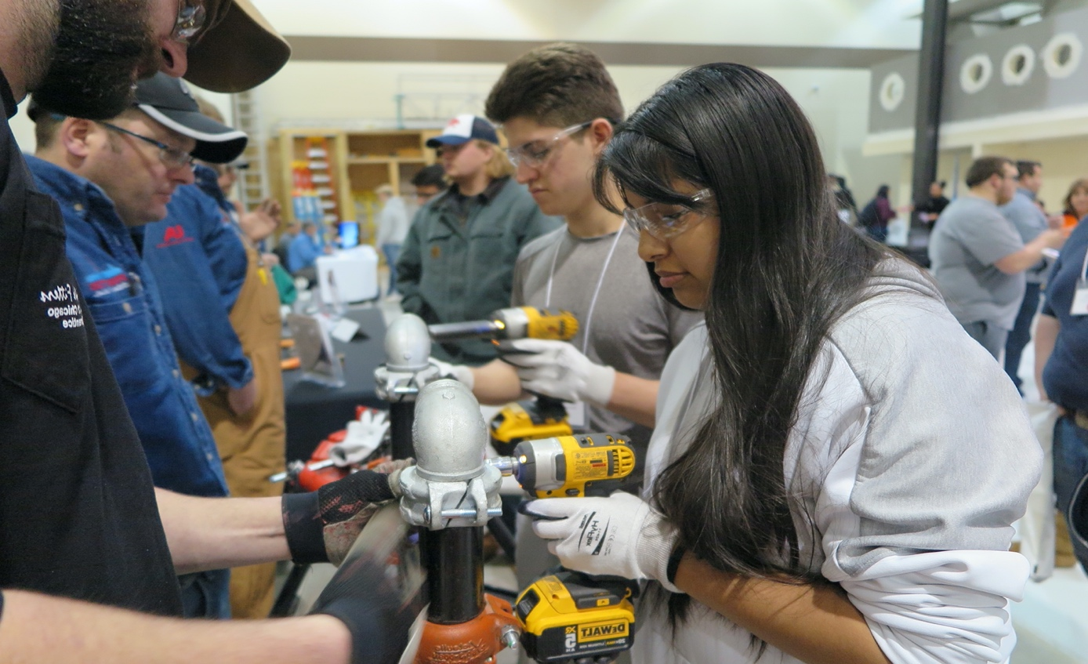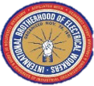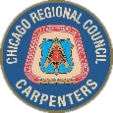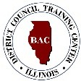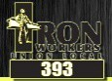

**- ------------------------------------**

APPRENTICESHIP EXPO

Save the Date

**- ------------------------------------**

**November 15, 2022**

**8:30 a.m. – 1:30 p.m.**

**Painters District Council No. 30 1905 Sequoia Dr.**

**Aurora, IL**

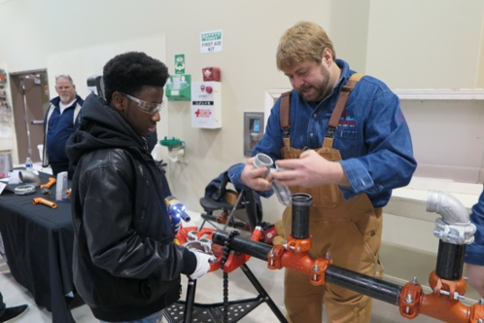

**Celebrate Apprenticeship Week**

Interact with over 600 middle and high school students from the Fox Valley area at the second annual Apprenticeship Expo hosted by the Fox Valley Building Trades, Painters District Council 30, IBEW 461 and VALEES.

To secure booth space for your trade, complete the [registration](https://docs.google.com/forms/d/e/1FAIpQLSde6n32ykw70le1pSeq5osLKNtD0JFQM3mOm5VsgI_MxQbOdA/viewform?usp=sf_link) form by September 1, 2022.