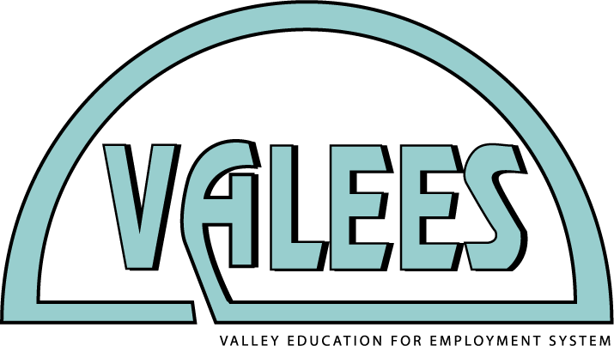

Graphic Communications
Student of the Year Competition
Virtual Competition – Friday, March 19, 2021

If you are nominated as the applicant from your high school or career center, you must:
1. Type your answers to this application;

2. Submit this signed application to VALEES via email (mborneman@waubonsee.edu) by Wednesday, March 3, 2021;

3. Submit a resume to VALEES via email (mborneman@waubonsee.edu) by Wednesday, March 3, 2021;

4. Be available from 9:00 a.m.–2:00 p.m. on Friday, March 19, 2021 via Zoom.

5. Bring your You and Yours Café YAY deliverables (see project description)

6. Bring a digital portfolio of previous work to the interview. A maximum of 8 portfolio pieces can be presented during the interview. The interview will take place over Zoom. Practice using Zoom.

First/Last Name: ______________________________________________________________

Address: ____________________________________________________________________

Email Address: _______________________________________________________________

Phone Number: _______________________________________________________________

High School or Career Center Name: ______________________________________________

- In what area of Graphic Communications do you excel?

- What areas of Graphic Communications would you like to learn more about and why?

- Name the Graphic Communications courses you have taken in high school.

- Why have you chosen to pursue Graphic Communications at a higher level?

- What are your immediate career plans and goals?

- What would receiving the Graphic Communications Student of the Year award mean to you?

____________________________________________________________________________
Applicant signature (sign above the line)

Date: _________________________________
Official high school use only
Number of days absent from start of school to March 1, 2021: _________________
Student’s GPA (indicate scale): ___________________
Official signature: ____________________________________________________________

