Foods/Culinary Arts Meeting Agenda
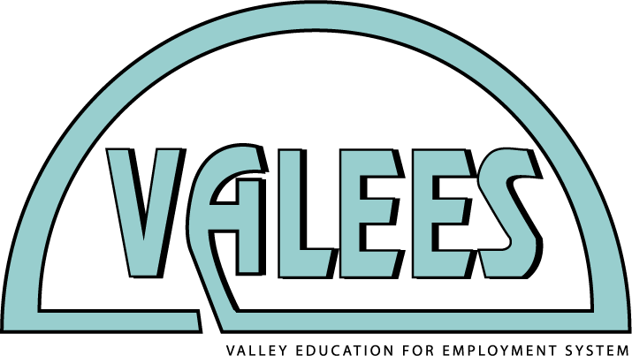
Tuesday, September 20, 2016
10:30 a.m. – 2:00 p.m. (Lunch provided)
Indian Valley Vocational Center

PLEASE RSVP TO MARY BORNEMAN (mborneman@waubonsee.edu) by
Tuesday, September 13, 2016 for an accurate lunch count

10:30 a.m. at Indian Valley Vocational Center (IVVC)
600 Lions Rd.
Sandwich, IL

Have photo ID to enter. Lunch prepared by students.

Agenda for time at Indian Valley Vocational Center
10:30 a.m. – Arrival
10:40 a.m. – 12:00 p.m.
1. Introductions and attendance
2. Mini-grants are available and due Friday, October 7, 2016
2. Review of ServSafe summer training and implementation. Mini-grant funding for ServSafe curriculum and testing.
3. VALEES Burger Cook-Off at Northern Illinois University (Friday, October 21, 9 a.m. – 2 p.m.) distribution of competition guidelines and day of logistics.
4. Discussion of professional development for FY17 – March workshop, field trip, etc.
12:00 p.m. – 1:00 p.m.
Lunch prepared and served by IVVC students
1:00 p.m. – 2:00 p.m.
Tour of IVVC and question and answer time. Bring items for discussion.
Calendar: Upcoming Events and Meetings
Event | Date | Time | Place
Mini-grant deadline | Friday, October 7 |  | To the VALEES office
Career Pathways Expo | Friday, October 14, 2016 | 8:30 a.m. – 1:30 p.m. | Waubonsee Community College, Sugar Grove Campus
VALEES Burger Cook-Off | Friday, October 21, 2016 | 9:00 a.m. – 2:00 p.m. | Northern Illinois University  Wurtz Hall (WZ 306-Food Lab)
Building Partnerships for America’s Future (all-day inservice) | Friday, March 3, 2017 | 7:30 a.m. – 2:30 p.m. | Waubonsee Community College, Sugar Grove Campus

