Automotive Technology
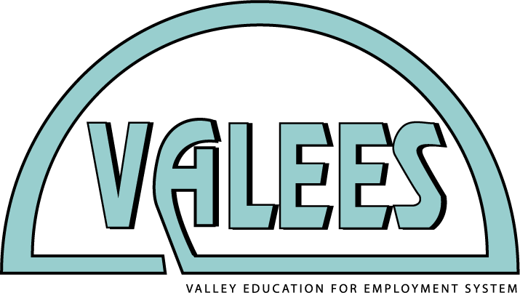
Program Committee Meeting
Wednesday, September 30, 2015
Building A, Room 122

Please RSVP to Mary Borneman by Wednesday, September 23, 2015 (mborneman@waubonsee.edu)

12:00 p.m. | Welcome, introductions and pizza
Meeting agenda | 1. Articulated credit – review course title  2. Professional development planning – March 4 host of automotive meeting, session ideas  3. Waubonsee skills competition planning  4. Advisory dinner planning  5. High school recruiting visits planning
2:00 p.m. | Dismissed

Calendar: Upcoming Events and Meetings

Event | Date | Place
Career Pathways Expo | Friday, October 9 | Waubonsee APC
Manufacturing Career Awareness | Friday, October 23 (tentative) | TBD
Annual in-service, Building Partnerships for America’s Future | Friday, March 4 | Waubonsee APC

