Fashion & Clothing Program Committee
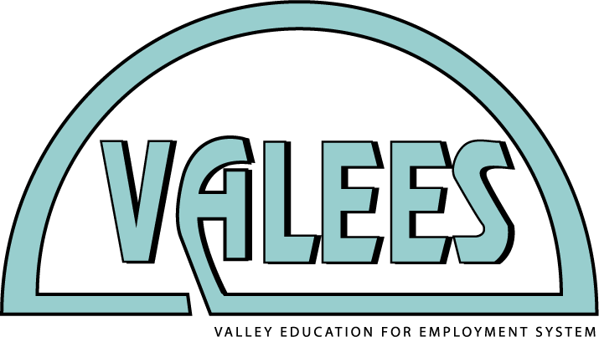
Tuesday, October 11, 2016
Creative Sewing
11 N. 1st St., Geneva

Please RSVP to Mary Borneman by Monday, October 3, 2016 for an accurate count of materials (mborneman@waubonsee.edu)

Program committee meeting & technical skill workshop with Lisa Flyte from
Creative Sewing Center
11 N. 1st St.
Geneva, IL 60134

8:30 a.m. | Welcome, introductions and attendance roster  VALEES updates including dates to remember, mini-grant availability
9:00 a.m. | Workshop – technical skill development
11:30 a.m. | Lunch provided
12:15 p.m. | Workshop continues
1:30 – 2:00 p.m. | Wrap-up and planning next meeting

Calendar: Upcoming Events and Meetings

Event | Date | Time | Place
Career Pathways Expo | Friday, October 14, 2016 | All-day | Waubonsee Community College, Sugar Grove Campus
Building Partnerships for America’s Future | Friday, March 3, 2017 | 7:30 a.m. – 2:30 p.m. | Waubonsee Community College, Sugar Grove Campus

