Business, Marketing & Computer Education
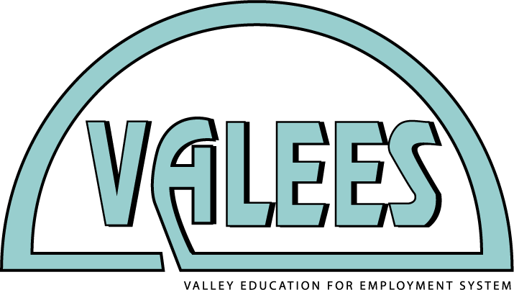
Thursday, September 17, 2015

Please RSVP to Mary Borneman by Thursday, September 10, 2015 (mborneman@waubonsee.edu)

Professional development with Northern Illinois University’s Center for Economic Education and program committee meetings.
Where: Akerlow 202, Waubonsee Community College, Sugar Grove Campus
8:30 a.m. | Introductions and welcome
9:00 a.m. | Business and marketing (including accounting and economics teachers) to Henning 100 for Virtual Economics with NIU.  Computer education teachers remain in Akerlow 202 for job market discussion and review of articulated credit with Waubonsee including development of new agreements.
11:00 a.m. | Move to Akerlow 202
11:30 a.m. – 12:15 p.m. | Lunch provided in Akerlow 202
12:15 p.m. – 2:00 p.m. | Breakout groups  Business and marketing  Accounting – review articulated credit agreement with Waubonsee  Computer education – discuss articulated credit agreement with Waubonsee  *Bring curriculum materials including course outlines, projects, assessments, textbooks to share and discuss with colleagues.

Calendar: Upcoming Events and Meetings

Event | Date | Time | Place
Career Pathways Expo | Friday, October 9 | All-day | Waubonsee APC

