Business Card Finishing

Now that you have completed your 10 business cards, you are going to choose your final and set it up to print 50 of them.

The process looks like this:

- set up an artboard in your business card file that is 3.5 x 2”.
- Copy your artwork to this artboard
- Make any final adjustments, keep in mind:
  - Your name should stand out
  - Your information should be no larger than 12 pt text
  - Your text and elements should be approximately 1/8” from the edge of your business card so that information is not cut off. The only exception would be if you have a bleed and your background is running over the edge of your business card.
- Save your file in its original illustrator format
- Save your file as a PDF
- Open InDesign
- Go to InDesign Menu>>Preferences>>Units & Increments. Change horizontal unit and vertical units to inches.
- Go to Fill>>New Document and make the following settings in the box.
  - 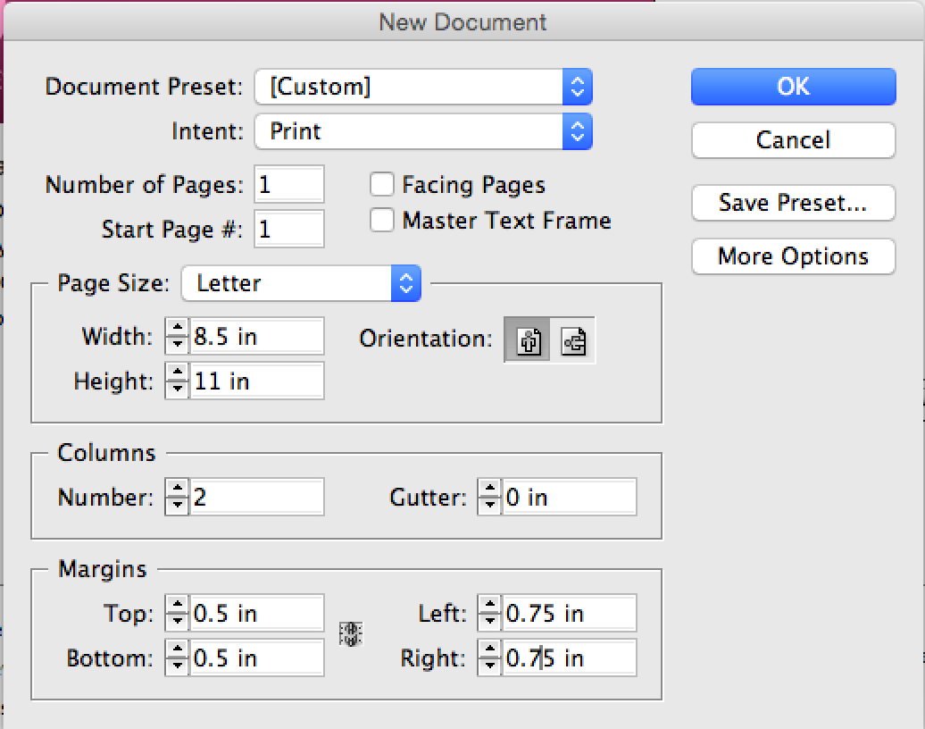
- Go to File>>Place
- Click on Show Import Options at the bottom of the dialog box, select your final business PDF card file.
- Select the artboard
- Single click in the top left corner of your guides on the document page to place the file.
- While the image is selected, go to Edit Menu>>Step and Repeat
- Turn on Create as grid, 5 rows, 2 columns, Offset vertical to 2, and Offset Horizontal to 3.5, click OK.
- Next go to File>>Print
  - For Gaia/Phaser 7800
    - Choose Gaia/Phaser 7800
    - Type in the number of copies
    - On the left, click on setup and choose centered for the page position
    - Set paper size to US Letter
    - Click on Printer
    - Change layout to Xerox features
    - Change paper type to cardstock
    - Choose print 1 sided
    - Do NOT set where to get the paper from, the printer will decide this for you.
    - Click Print
    - Check the quantity again, click print
    - If you are printing a 2 sided business card, talk to Mrs. Larsen
- Cut your business cards out, follow the information on the Pneumatic paper cutter.

Evaluation

Final business card layout 0 1 2 3 4 5
Printing 0 1 2 3 4
Cutting 0 1 2 3 4

